PRESS RELASE

COMMUNICATIONS AND MEDIA TEAM OF THE 2023 ASEAN SUMMIT

No.63/SP/TKM-ASEAN2023/ENG/5/2023

BNPT Ensures the Security of All 42nd ASEAN Summit Venues

West Manggarai, 10 May 2023 – The National Counter Terrorism Agency of the Republic of Indonesia (BNPT RI) has a strategic responsibility in supporting the security of the 42nd ASEAN Summit 2023, which will be held from May 9 to 11 in Labuan Bajo, East Nusa Tenggara.

Head of BNPT RI, Commissioner General of Police Rycko Amelza Dahniel, emphasized that his party has a responsibility to contribute to the security of the venue and the personnel involved.

"We run background checks on employees working in venues and activity locations, including accommodations for tourist attractions that will be visited by heads of state, to ensure that they are truly accountable and fall within the category of clear," he explained, during the Security Coordination Meeting for 2023 ASEAN Summit VVIP at the ASEAN Summit Command Center, which was convened by the TNI Commander Admiral TNI Yudo, on Wednesday, 10 May 2023.

The security standard adheres to Regulation of BNPT No. 3 of 2020 on the Protection of Infrastructure for Strategic Vital Objects and Public Facilities in the Prevention of Criminal Acts of Terrorism.

Rycko also emphasized that as a state agency, BNPT RI contributes to the success of the ASEAN Summit by presenting a secure, comfortable, and terror-free environment.

"As a state agency, it is BNPT's responsibility to ensure that all security facilities and infrastructure in all venues, including the event site in Labuan Bajo, meet security standards, with a focus on security awareness of the terrorist attacks," he said.

Additionally, BNPT RI evaluated a number of venues for coordinating activities involving delegations from countries participating in the ASEAN Summit.

The locations include the Meruorah Hotel, Ayana Hotel, Sudamala Hotel, Bintang Flores Hotel, and Puncak Waringin, as well as Golo Mori that which become one of the future Labuan Bajo's tourist destinations. (InfoPublik/TR/Elvira/SC/PPR)

***

For more information, please contact:

Director General of Public Information and Communications of the Ministry of Communications and Informatics – Usman Kansong (0816785320).

Get other information at http://asean2023.id, https://infopublik.id/kategori/asean-2023, and https://indonesia.go.id/kategori/ragam-asean-2023

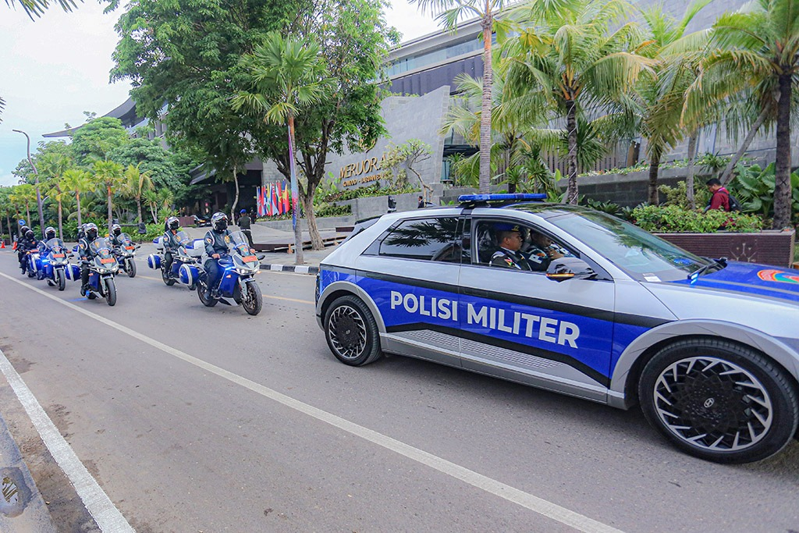

The joint task force securing the 42nd ASEAN Summit in Labuan Bajo, Wednesday (10 May). Photo: Agus Siswanto/InfoPublik

